

Recommendation from main supervisor
Name of applicant: Jonas Munk Jensen
Name of main supervisor: Annelli Sandbæk
Place of employment: Public Health

Have you attended a PhD supervision course:
Yes - which:
No - when do you plan to attend the PhD supervision course: ???
I contribute to the PhD study programme in general as;
Pre assessor:
Teacher of PhD courses:
Chairman in assessment committees:
Other: Supervisor for a large number of PhD students
With this recommendation the main supervisor agrees to act as a main supervisor for the applicant. Also the main supervisor vouches for the completion of the PhD study programme.
Recommendation
I hereby confirm that I will be the main supervisor for Jonas Munk Jensen in his PhD project, Optimizing Self-Management in Type 2 Diabetes: The Role of High-Intensity Interval Training in Enhancing Health Outcomes. The project aims to generate knowledge that may contribute to the development of more effective and engaging interventions for people living with Type 2 Diabetes. This is particularly timely and relevant, as it coincides with the planned healthcare reform set to take effect in 2027, where the responsibility for delivering diabetes self-management programs will be transferred from municipalities to regional authorities. Findings from this project may provide valuable insights for policymakers in shaping evidence-based interventions during this transition.
Jonas Munk Jensen has been a valuable part of the LIVING project from the beginning. He was instrumental in identifying the opportunity to assess the additional effects of exercise while evaluating the Lev Livet DSMP and has since played a central role in facilitating this process. He has practical experience from working in the setting we are exploring and has, since 2020, established strong collaborations with municipalities across the Central Denmark Region.
I find Jonas highly qualified to carry out the planned studies and to be part of a PhD program. I look forward to continuing our collaboration and working with the research group he has established.

Date: 09.02.2025

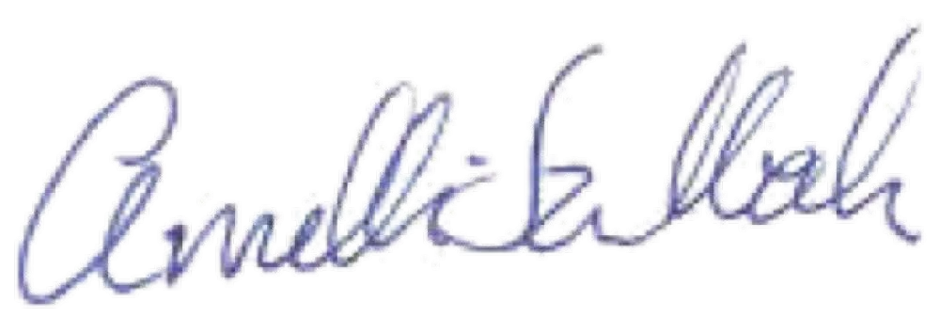
________________________________________
Main supervisor’s signature

